**DEVELOP A PYTHON SCRIPT**

|  |  |
| --- | --- |
| Team ID | PNT2022TMID13519 |
| Project Name | Real time river water quality monitoring and control system |
| Maximum Marks | 4 Marks |

**PYTHON CODE**

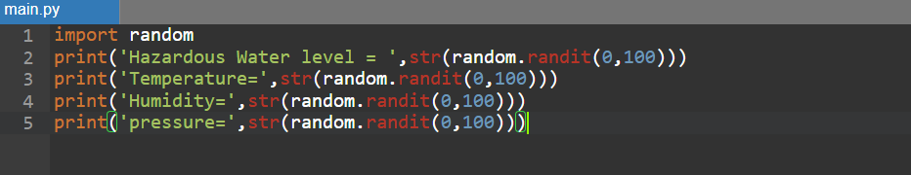

**OUTPUT**

